MINI PROJECT REPORT

RAILWAY RESERVATION SYSTEM USING PYTHON AND MYSQL
Submitted by:
Sr. No. | Name of Student | Roll Number
1 | Neev Rungta | S034
2 | Pranav Sancheti | S041
3 | Rajveer Gupta | S043
4 | Yogesh Maheta | S063
Subject: DBMS
Class/Division: A-2
Department: AI&DS
Academic Year: 2026–2027

Railway Reservation System using Python, Tkinter, and MySQL

TOPIC DETAILS
The Staff Database Management System is a mini-project developed using Python, Tkinter, and MySQL to store and manage staff information efficiently. The system provides a graphical user interface (GUI) through which users can insert new staff records, display existing records, update staff details, and delete staff information. MySQL is used as the backend database to store staff ID, name, phone number, email address, and residential address. Python connects the application to the database using the mysql.connector library, while Tkinter provides input fields, buttons, labels, and a table to display the records. The system uses SQL queries to perform database operations and includes error-handling mechanisms to display database-related errors. This project demonstrates the practical application of Python programming, database connectivity, SQL commands, and GUI development in creating a simple and user-friendly database management application.

SOFTWARE REQUIREMENTS
Python

HARDWARE:
MYSQL

ER DIAGRAM

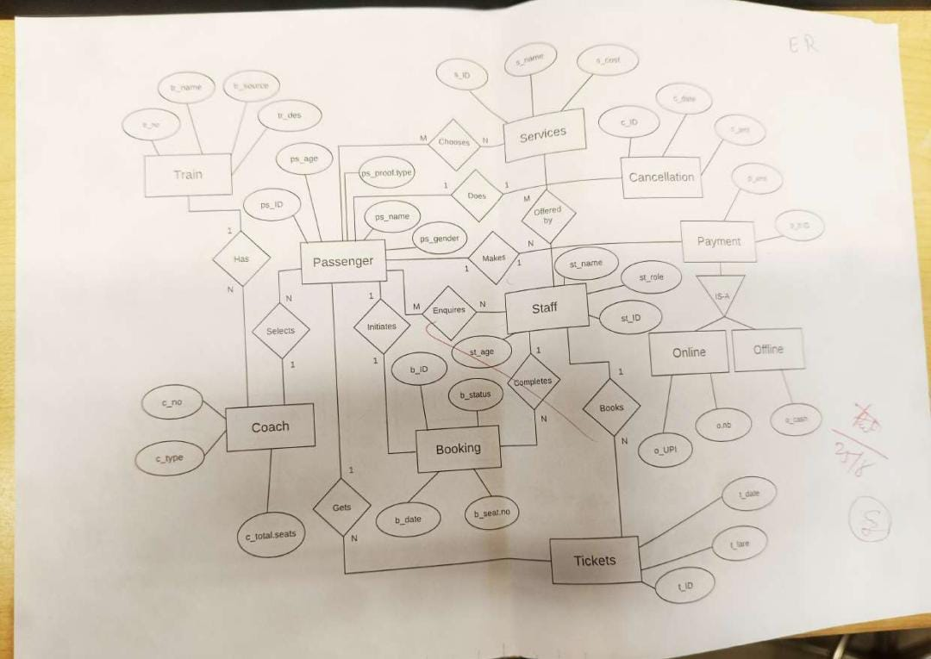

PYTHON CODE
File Name: staff_database.py
from tkinter import *
from tkinter import messagebox
from tkinter import ttk
import mysql.connector
conn = mysql.connector.connect(
user="root",
password="Mysql@123",
host="localhost",
database="S_RAILWAY"
)
cursor = conn.cursor()
class Staff:
def __init__(self, root):
self.root = root
self.root.title("Railway Management System")
self.root.geometry("600x500")
self.menu = Frame(root)
self.menu.pack(pady=20)
Label(
self.menu,
text="Railway MANAGEMENT SYSTEM",
font=("Arial", 16, "bold")
).grid(row=0, column=0, columnspan=2, pady=15)
Button(
self.menu, text="Insert", width=15,
command=self.insert_form
).grid(row=1, column=0, padx=10, pady=10)
Button(
self.menu, text="Update", width=15,
command=self.update_form
).grid(row=1, column=1, padx=10, pady=10)
Button(
self.menu, text="Delete", width=15,
command=self.delete_form
).grid(row=2, column=0, padx=10, pady=10)
Button(
self.menu, text="Show", width=15,
command=self.show_staff
).grid(row=2, column=1, padx=10, pady=10)
self.area = Frame(root)
self.area.pack(fill=BOTH, expand=True, padx=15, pady=10)
def clear_area(self):
for widget in self.area.winfo_children():
widget.destroy()
def create_fields(self, data=None):
fields = [
("Staff ID", "st_id"),
("Staff Name", "st_name"),
("Staff Role", "st_role"),
("Staff Age", "st_age"),
("Staff Salary", "st_salary"),
("Staff Gender (M/F)", "st_gender")
]
self.entries = {}
for i, (label, key) in enumerate(fields):
Label(self.area, text=label + ":").grid(
row=i, column=0, sticky=W, padx=10, pady=5
)
entry = Entry(self.area, width=25)
entry.grid(row=i, column=1, padx=10, pady=5)
if data:
entry.insert(0, str(data[i]))
self.entries[key] = entry
return self.entries
def get_values(self):
st_id = int(self.entries["st_id"].get())
st_name = self.entries["st_name"].get().strip()
st_role = self.entries["st_role"].get().strip()
st_age = int(self.entries["st_age"].get())
st_salary = int(self.entries["st_salary"].get())
st_gender = self.entries["st_gender"].get().strip().upper()
if not st_name or not st_role:
raise ValueError("Name and role cannot be empty.")
if st_gender not in ("M", "F"):
raise ValueError("Gender must be M or F.")
return (
st_id, st_name, st_role,
st_age, st_salary, st_gender
)
# INSERT
def insert_form(self):
self.clear_area()
Label(
self.area, text="INSERT STAFF",
font=("Arial", 12, "bold")
).grid(row=0, column=0, columnspan=2, pady=10)
self.create_fields()
Button(
self.area, text="Save",
command=self.insert_staff
).grid(row=7, column=1, pady=10)
def insert_staff(self):
try:
values = self.get_values()
sql = """
INSERT INTO Staff
(st_id, st_name, st_role, st_age,
st_salary, st_gender)
VALUES (%s, %s, %s, %s, %s, %s)
"""
cursor.execute(sql, values)
conn.commit()
messagebox.showinfo(
"Success", "Staff inserted successfully."
)
self.insert_form()
except ValueError as e:
messagebox.showerror("Input Error", str(e))
except mysql.connector.Error as e:
conn.rollback()
messagebox.showerror("Database Error", str(e))
def update_form(self):
self.clear_area()
Label(
self.area, text="UPDATE STAFF",
font=("Arial", 12, "bold")
).grid(row=0, column=0, columnspan=2, pady=10)
Label(self.area, text="Enter Staff ID:").grid(
row=1, column=0, padx=10, pady=10
)
self.update_id = Entry(self.area, width=25)
self.update_id.grid(row=1, column=1, padx=10, pady=10)
Button(
self.area, text="Search",
command=self.find_staff
).grid(row=2, column=1, pady=10)
def find_staff(self):
try:
st_id = int(self.update_id.get())
cursor.execute(
"SELECT st_id, st_name, st_role, st_age, "
"st_salary, st_gender FROM Staff WHERE st_id=%s",
(st_id,)
)
data = cursor.fetchone()
if data is None:
messagebox.showinfo(
"Not Found", "Staff ID not found."
)
return
self.clear_area()
Label(
self.area, text="EDIT STAFF DETAILS",
font=("Arial", 12, "bold")
).grid(row=0, column=0, columnspan=2, pady=10)
self.create_fields(data)
self.entries["st_id"].config(state="readonly")
Button(
self.area, text="Update",
command=self.update_staff
).grid(row=7, column=1, pady=10)
except ValueError:
messagebox.showerror(
"Input Error", "Enter a valid Staff ID."
)
except mysql.connector.Error as e:
messagebox.showerror("Database Error", str(e))
def update_staff(self):
try:
values = self.get_values()
sql = """
UPDATE Staff
SET st_name=%s, st_role=%s, st_age=%s,
st_salary=%s, st_gender=%s
WHERE st_id=%s
"""
cursor.execute(sql, (
values[1], values[2], values[3],
values[4], values[5], values[0]
))
conn.commit()
if cursor.rowcount == 0:
messagebox.showinfo(
"Information",
"No changes made, or staff ID not found."
)
else:
messagebox.showinfo(
"Success", "Staff updated successfully."
)
self.update_form()
except ValueError as e:
messagebox.showerror("Input Error", str(e))
except mysql.connector.Error as e:
conn.rollback()
messagebox.showerror("Database Error", str(e))
def delete_form(self):
self.clear_area()
Label(
self.area, text="DELETE STAFF",
font=("Arial", 12, "bold")
).grid(row=0, column=0, columnspan=2, pady=10)
Label(self.area, text="Enter Staff ID:").grid(
row=1, column=0, padx=10, pady=10
)
self.delete_id = Entry(self.area, width=25)
self.delete_id.grid(row=1, column=1, padx=10, pady=10)
Button(
self.area, text="Delete",
command=self.delete_staff
).grid(row=2, column=1, pady=10)
def delete_staff(self):
try:
st_id = int(self.delete_id.get())
cursor.execute(
"SELECT st_name FROM Staff WHERE st_id=%s",
(st_id,)
)
data = cursor.fetchone()
if data is None:
messagebox.showinfo(
"Not Found", "Staff ID not found."
)
return
confirm = messagebox.askyesno(
"Confirm Delete",
"Delete staff member " + data[0] + "?"
)
if confirm:
cursor.execute(
"DELETE FROM Staff WHERE st_id=%s",
(st_id,)
)
conn.commit()
messagebox.showinfo(
"Success", "Staff deleted successfully."
)
self.delete_form()
except ValueError:
messagebox.showerror(
"Input Error", "Enter a valid Staff ID."
)
except mysql.connector.Error as e:
conn.rollback()
messagebox.showerror("Database Error", str(e))
def show_staff(self):
self.clear_area()
Label(
self.area, text="ALL STAFF MEMBERS",
font=("Arial", 12, "bold")
).pack(pady=5)
columns = (
"st_id", "st_name", "st_role",
"st_age", "st_salary", "st_gender"
)
table = ttk.Treeview(
self.area, columns=columns,
show="headings", height=8
)
headings = [
("st_id", "ID"),
("st_name", "Name"),
("st_role", "Role"),
("st_age", "Age"),
("st_salary", "Salary"),
("st_gender", "Gender")
]
for col, heading in headings:
table.heading(col, text=heading)
table.column(col, width=80, anchor=CENTER)
table.pack(fill=BOTH, expand=True)
try:
cursor.execute(
"SELECT st_id, st_name, st_role, st_age, "
"st_salary, st_gender FROM Staff ORDER BY st_id"
)
for row in cursor.fetchall():
table.insert("", END, values=row)
except mysql.connector.Error as e:
messagebox.showerror("Database Error", str(e))
root = Tk()
obj = Staff(root)
root.mainloop()
cursor.close()
conn.close()

SCREENSHOTS OF OUTPUTS
Screenshot 1: Main Application Window
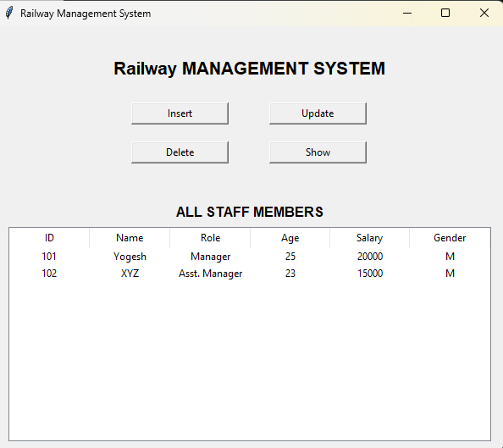
Description: This screenshot shows the Staff Database application with input fields for staff ID, name, role, salary and gender along with the Insert, Show, Update, and Delete buttons.
Screenshot 2: Insert Staff
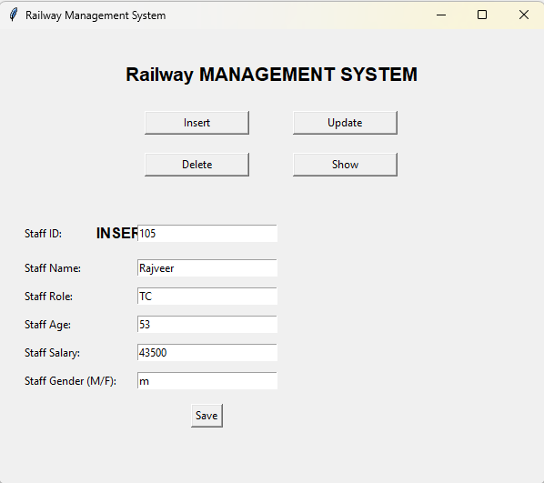
Description: This screenshot shows a STAFF record entered in the form and the output message displayed after a successful insertion.
Screenshot 3: Display Staff Records
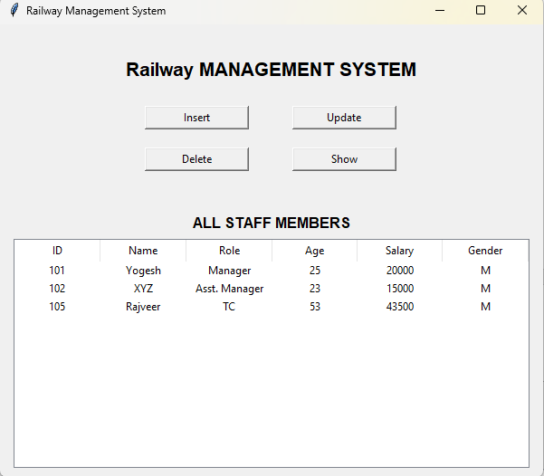
Description: This screenshot shows the staff records retrieved from the MySQL database and displayed in the Treeview table.

Screenshot 4: Update Staff
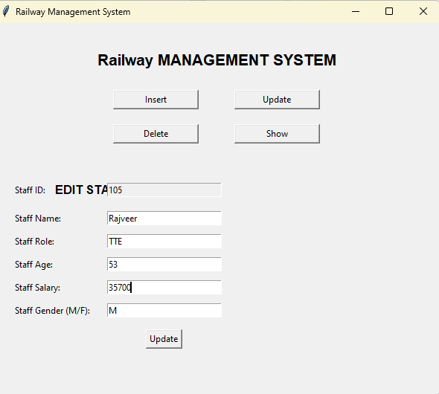
Description: This screenshot shows the application after modifying the details of an existing staff.

Screenshot 5: Delete Staff
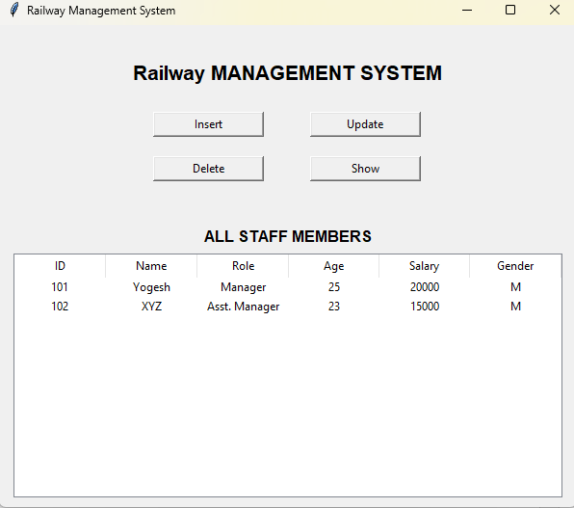
Description: This screenshot shows the application after deleting a staff record from the database.

Screenshot 6: MySQL Database Output
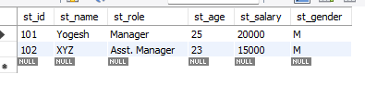
Description: This screenshot shows the staff table and the results of executing SELECT * FROM staff; in MySQL Workbench or the MySQL command line.
Important: Run the program and capture the actual outputs for these sections. Do not use sample or fabricated screenshots as proof of execution.

CONCLUSION

The Railway Reservation System was designed to demonstrate the integration of Python, Tkinter, and MySQL in a practical application. It provides basic functionality for inserting, displaying, updating, and deleting staff records through a graphical user interface. The project helps develop an understanding of SQL queries, database connectivity, GUI components, and error handling. It also demonstrates how a database can be used to organize and maintain information efficiently. This mini-project provides a foundation for developing more advanced database management applications in the future.

GITHUB LINK:

